**Ex.No 12: DATABASE DESIGN AND IMPLEMENTATION PHARMACY MANAGEMENT SYSTEM**

**PROBLEM STATEMENT:**

Develop a new Pharmacy Management System (PMS) to replace the existing inefficient system. The new PMS should centralize data management, automate administrative processes, and enable online access to resources. The goal is to enhance efficiency, transparency, and accessibility for customers, faculty, and administrative staff.

# AIM:

To create a database for a Pharmacy management system using MySQL and implement it using VB REQUIRED AND PROCEDURE

# Facilities required to do the experiment:

|  |  |  |
| --- | --- | --- |
| **Sl.No.** | **Facilities required** | **Quantity** |
| 1 | System | 1 |
| 2 | Operating System | Windows XP |
| 3 | Front end | JAVA SWING |
| 4 | Back end | MySQL |
|  |  |  |

**Procedure for doing the experiment:**

|  |  |
| --- | --- |
| **Step**  **no.** | **Details of the step** |
| 1 | Create a database for pharmacy which request the using SQL |
| 2 | Establish JDBC connection |
| 3 | Write the appropriate program in Java. |
| 4 | Run the Project. |

**ER DIAGRAM:**

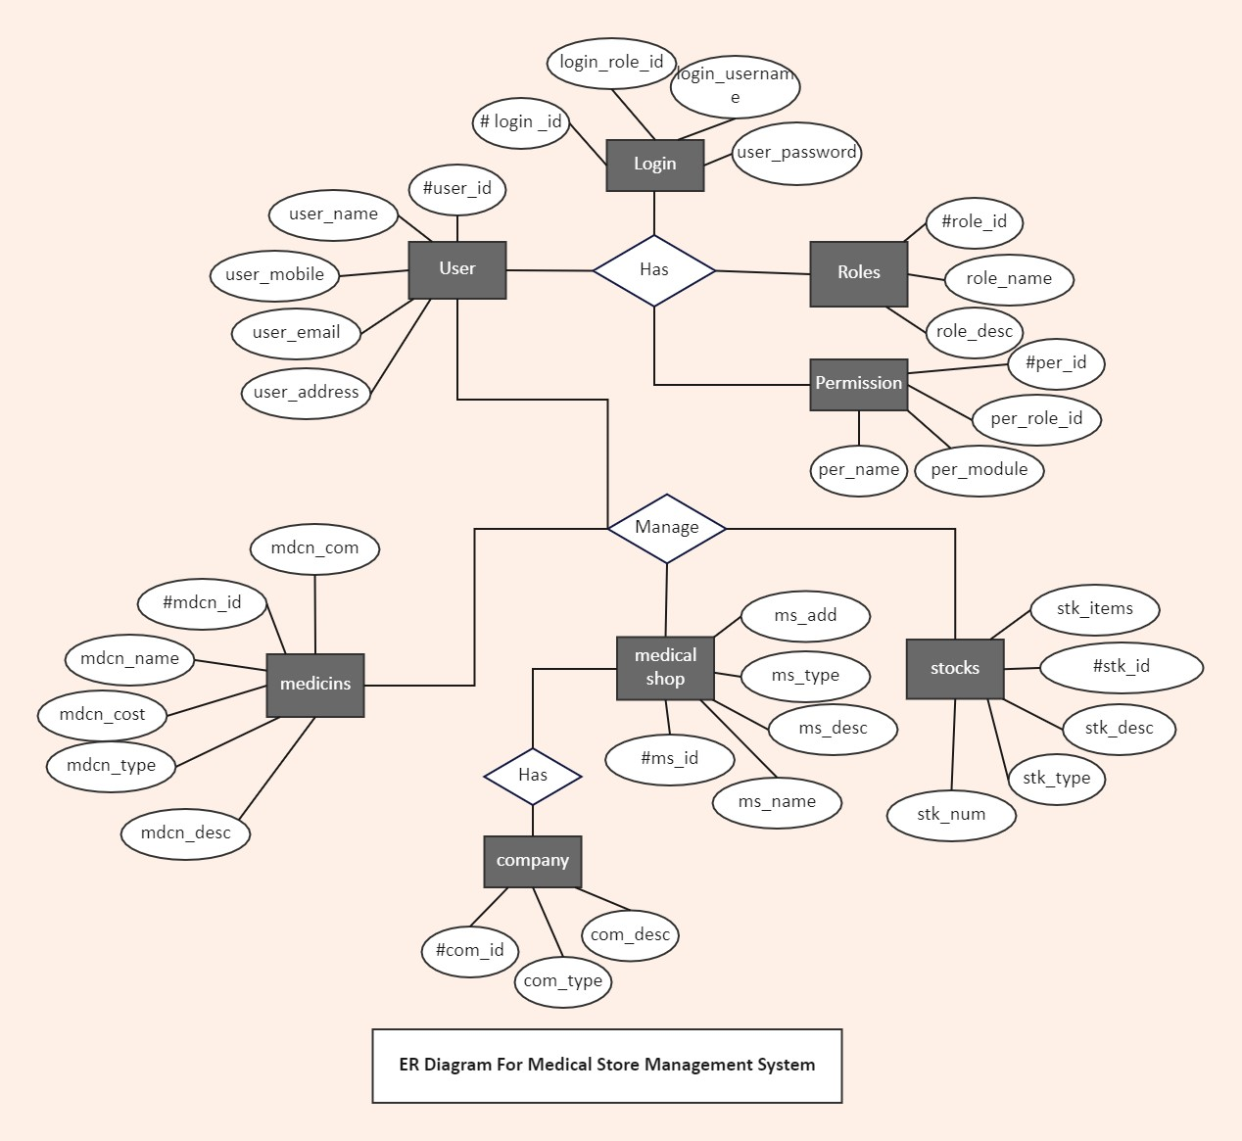

**Use of Frontend tools to manipulate database:**

**Frame:**

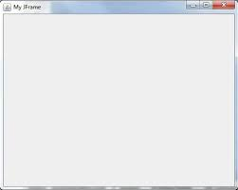 JFrame frame= new Jframe(“Login”);

frame.setDefaultCloseOperation(JFrame.*EXIT_ON_CLOSE*);

frame.setBounds(100, 50, 1083, 646);

contentPane = new JPanel();

contentPane.setBorder(new EmptyBorder(5, 5, 5, 5));

frame.setContentPane(contentPane);

contentPane.setLayout(null);

**Label:**  

JLabel lblNewLabel = new JLabel("PHARMACY MANAGEMENT SYSTEM");

lblNewLabel.setFont(new Font("Arial", Font.*BOLD*, 35));

lblNewLabel.setHorizontalAlignment(SwingConstants.*CENTER*);

lblNewLabel.setBounds(397, 25, 273, 41);

contentPane.add(lblNewLabel);

**TextField:**

idfield = **new** JTextField();

idfield.setBounds(246, 75, 204, 31);

panel_1.add(idfield);

idfield.setColumns(10);

**Table:**

table = **new** JTable();

tab.setViewportView(table);

DisplayTable();

**public** **void** DisplayTable()

{

**try** {

pat=con.prepareStatement("select * from pharmm ");

ra=pat.executeQuery();

table.setModel(DbUtils.*resultSetToTableModel*(ra));

}

**catch**(SQLException e) {

e.printStackTrace();

}

}

**Button:**



JButton btnBack = new JButton("BACK");

btnBack.addActionListener(new ActionListener() {

public void actionPerformed(ActionEvent e) {

dispose();

home ah = new home();

ah.setTitle("home");

ah.setVisible(true);

}

});

LOGIN PAGE:

ADMIN PAGE:

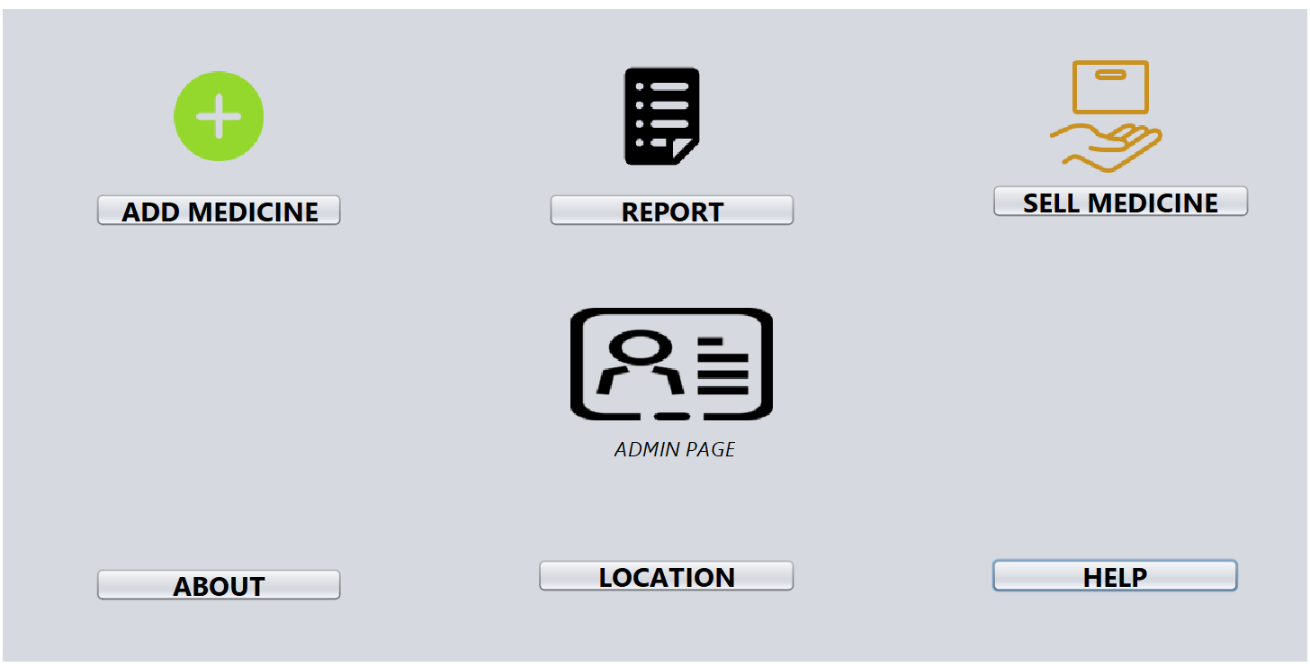

USER PAGE:

ADD MEDICINE:

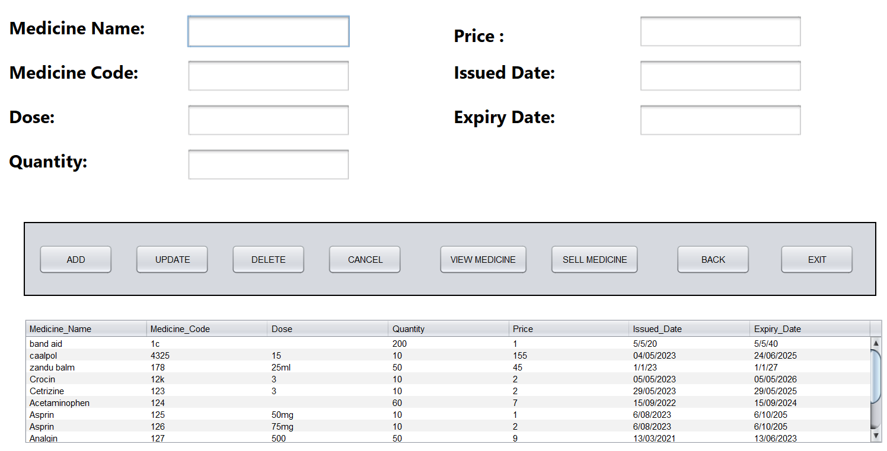

REPORT:

SELL MEDICINE:

**ABOUT PAGE:**

LOCATION PAGE:

HELP PAGE:

**Database Connectivity:**

public class DataBaseConnection {

static Connection *con*=null;

static final String *url*="jdbc:mysql://localhost:3306/pharmacy";

static final String *uname*="root";

static final String *password*="Pharm@123";

public static Connection getConnection(){

**try**{

Class.*forName*("com.mysql.jdbc.Driver");

*con*=DriverManager.*getConnection*(***url***,***uname***,***password***);

**return** *con*;

}

**catch**(Exception exp){

exp.printStackTrace();

**return** *con*;

}

}

**Insert:**

**try** {

String sql = "insert into pharmm values(?,?,?,?,?,?,?)";

PreparedStatement ps=conn.prepareStatement(sql);

ps.setString(1,jtxtName.getText());

ps.setString(2,jtxtRef.getText());

ps.setString(3,jtxtDose.getText());

ps.setString(4,jtxtNumberTablets.getText());

ps.setString(5,jtxtDailyDose.getText());

ps.setString(6,jtxtPossibleSideEffects.getText());

ps.setString(7,jtxtPharmID.getText());

ps.executeUpdate();

JOptionPane.showMessageDialog(this,"Saved"); }

**catch**(SQLException ex) {ex.printStackTrace();}

**Delete:**

try {

PreparedStatement ps=conn.prepareStatement("Delete from pharmm where Medicine_Code=?");

ps.setString(1,Medicine_Code);

ps.executeUpdate();

JOptionPane.showMessageDialog(this,"Deleted");

DisplayTable();}

catch(SQLException ex) {

ex.printStackTrace();

}

**REPORT :**

**Result:**

Thus the design and implementation of Pharmacy management system using MySQL was successfully done.